Q11.Write a SQL statement to change the email column of employees table with 'not available' for those employees whose JOB_ID is ‘FI_ACCOUNT’.

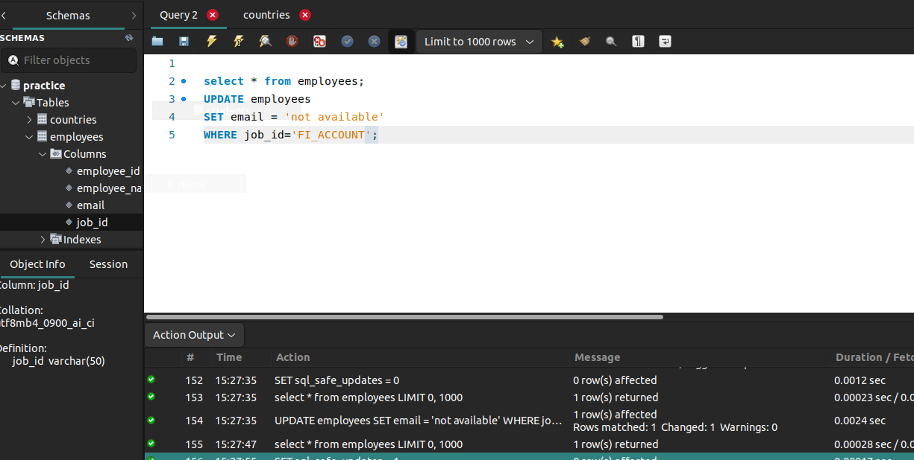

Q10.Write a SQL statement to change the email column of employees table with 'not available' for all employees.

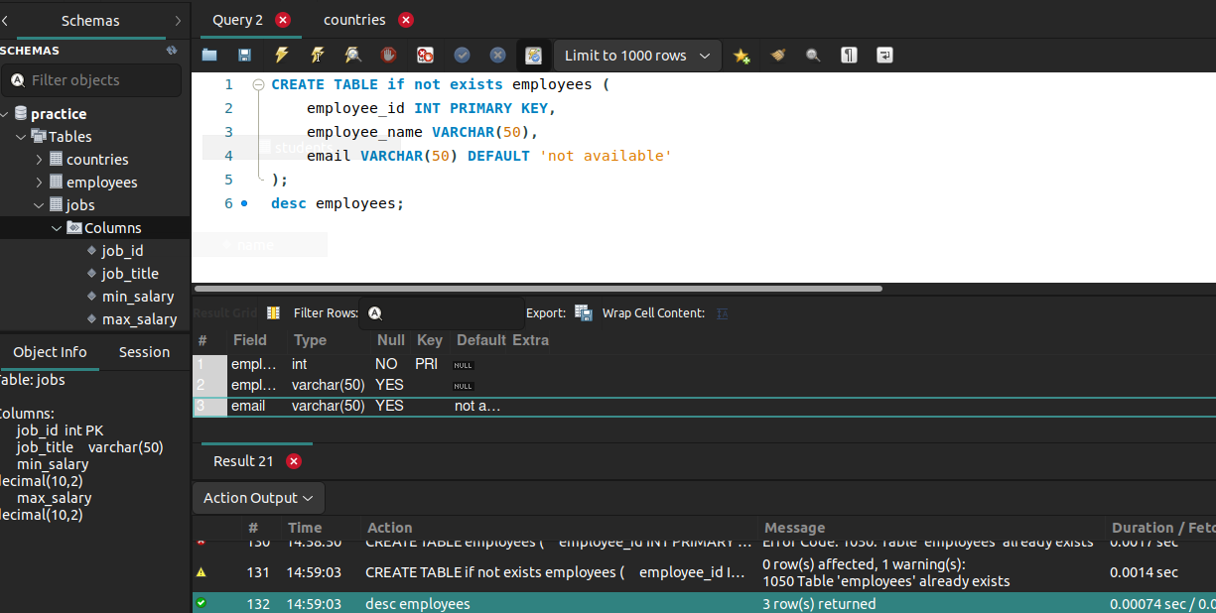

Q9.Write a SQL statement to add a columns ID as the first column of the table locations.

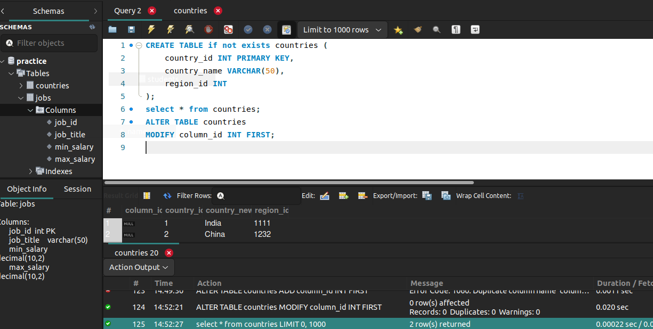

Q8.Write a SQL statement to rename the table countries to country_new.

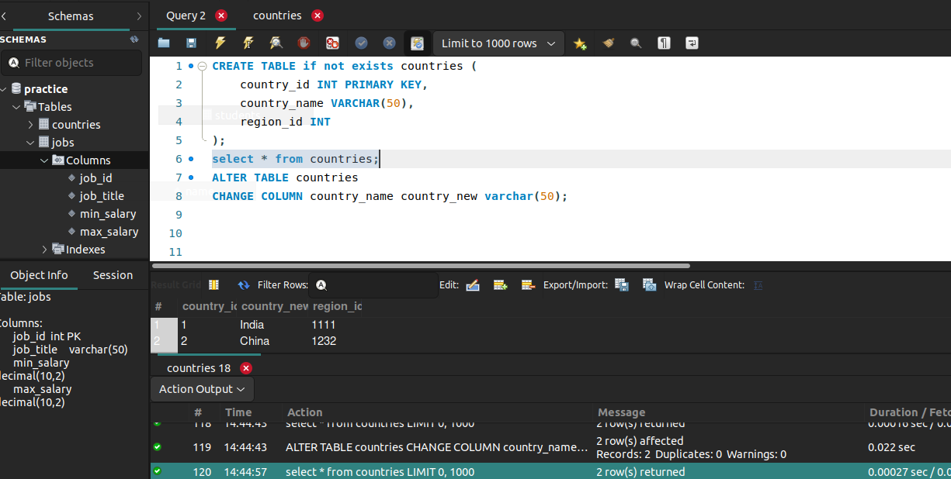

Q7.Write a SQL statement to create a table countries including columns country_id, country_name and region_id and make sure that the column country_id will be unique and store an auto incremented value.

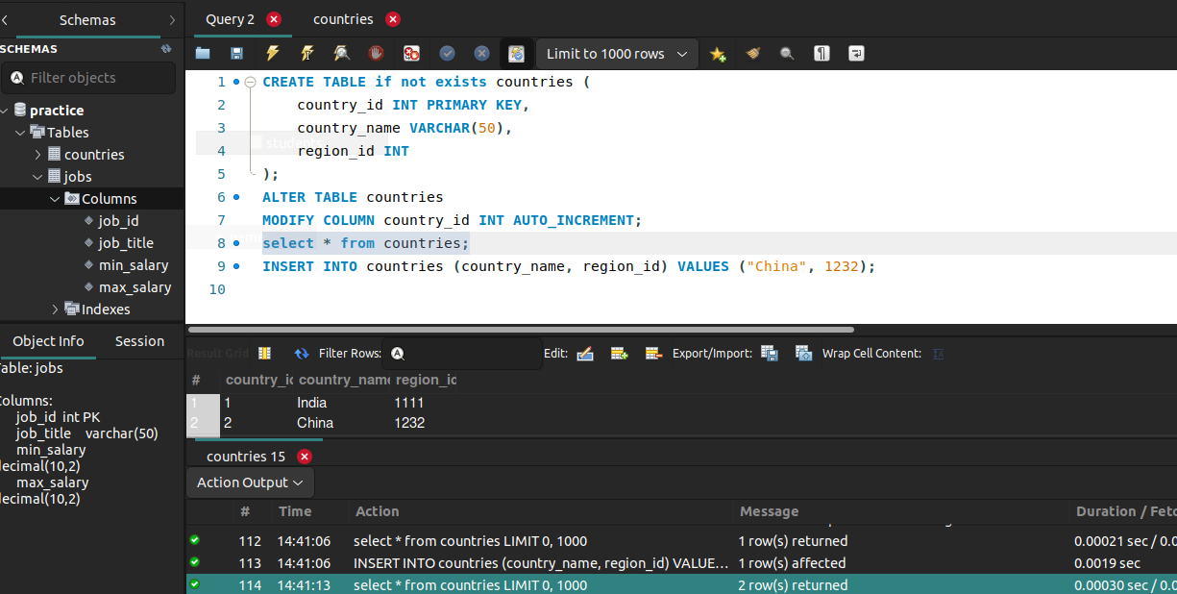

Q6.Write a SQL statement to create a table named countries including columns country_id, country_name and region_id and make sure that the country_id column will be a key field which will not contain any duplicate data at the time of insertion.

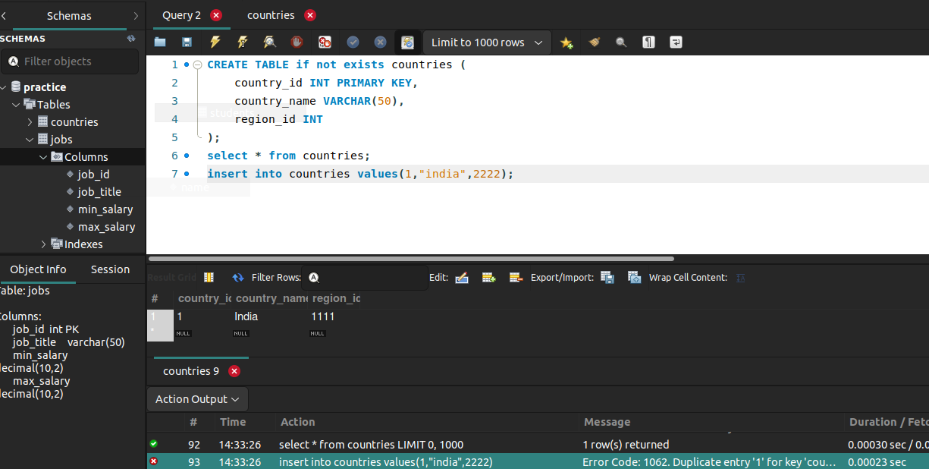

Q5.Write a SQL statement to create a table named jobs including columns job_id, job_title, min_salary and max_salary, and make sure that, the default value for job_title is blank and min_salary is 8000 and max_salary is NULL will be entered automatically at the time of insertion if no value assigned for the specified columns.

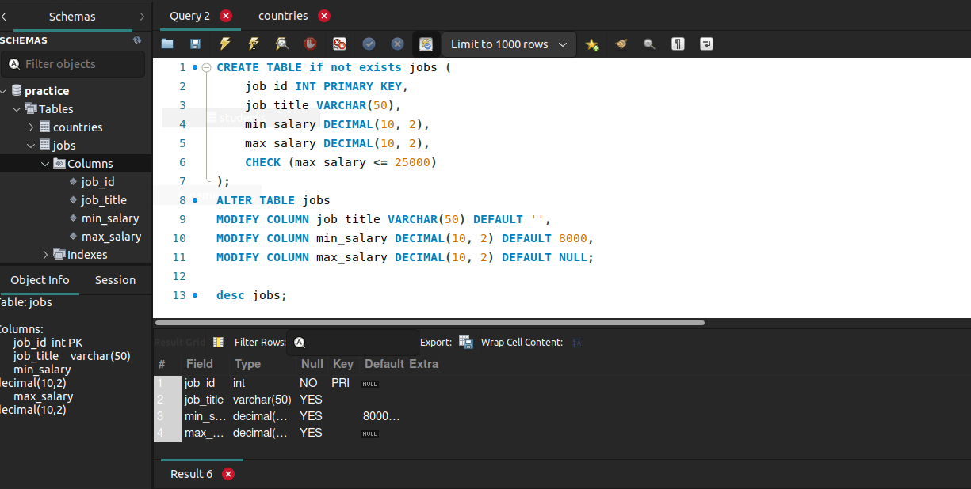

Q4.Write a SQL statement to create a table named countries including columns country_id,country_name and region_id and make sure that no duplicate data against column country_id will be allowed at the time of insertion.

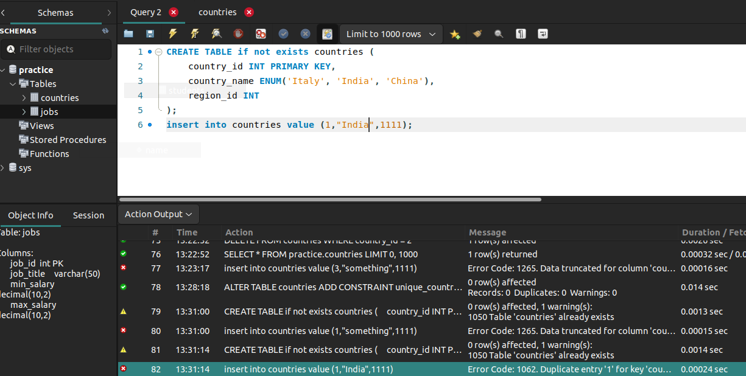
Q3.Write a SQL statement to create a table named countries including columns country_id, country_name and region_id and make sure that no countries except Italy, India and China will be entered in the table.

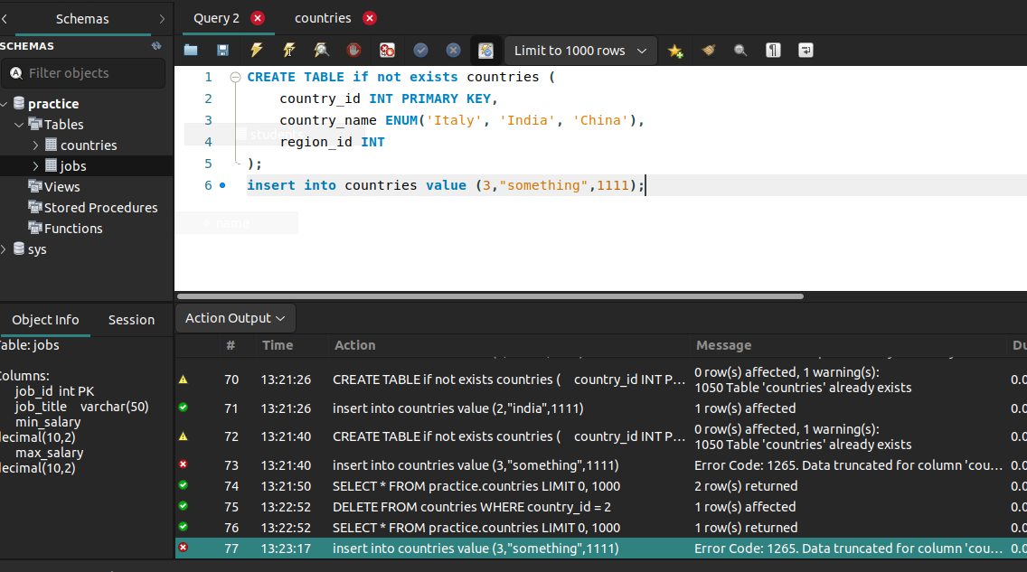

Q2.Write a SQL statement to create a table named jobs including columns job_id, job_title, min_salary, max_salary and check whether the max_salary amount exceeding the upper limit 25000.

Ans-
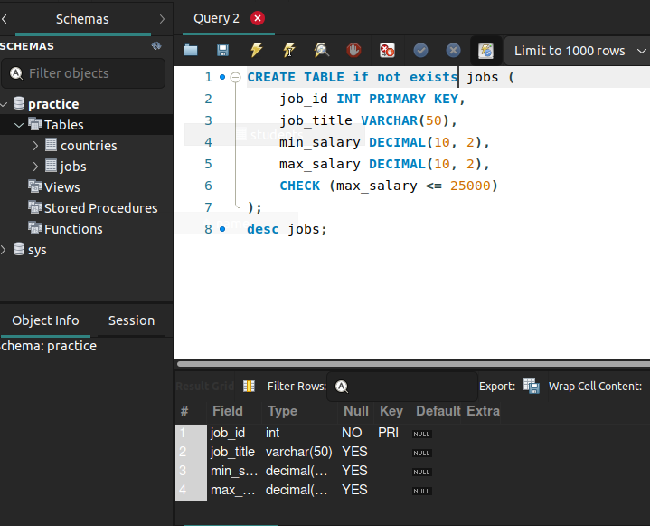

Q1.Write a SQL statement to create a simple table countries including columns country_id,country_name and region_id.

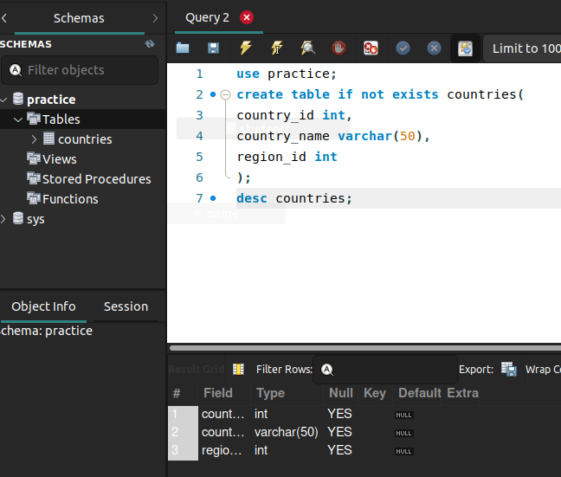
Ans-

